-

Modeling Assignment 2

By: Cody Fulford

University Of Calgary

CPSC 589 - Modeling

1. Since we are considering a b-spline, we know that all the weights are equal. We also know that all the control points are in the same position on the plane. Since the u increment is a constant value, the only part left is the layout of the knots. If the knot values are spaced out using a scheme where their distribution is even (standard/uniform) then the knot values will also be mirrored across the y axis and then the curve will be mirrored. If the knot distribution is un-even, then the knots will not be symmetrical across the y axis and the curve will likewise be asymmetrical
2. We know that for a 3rd degree spline that there will be 3 active control points active for any given point on the curve. We also know that the formula for each new element in deBoor’s recursion consists of [ωPi + (1-ω)Pi-1] where ω = $\frac{u-U_{i}}{U_{i+r-1}-U_{i}}$ where r is the current depth of recursion. We run this recursion over the 3 points until we get down to a single point.What we want is the general equation of Ci, 2. Which we can continue to expand to become. Which leads us to the conclusion that the equation of a third order b-spline with a uniform integer knot sequence is

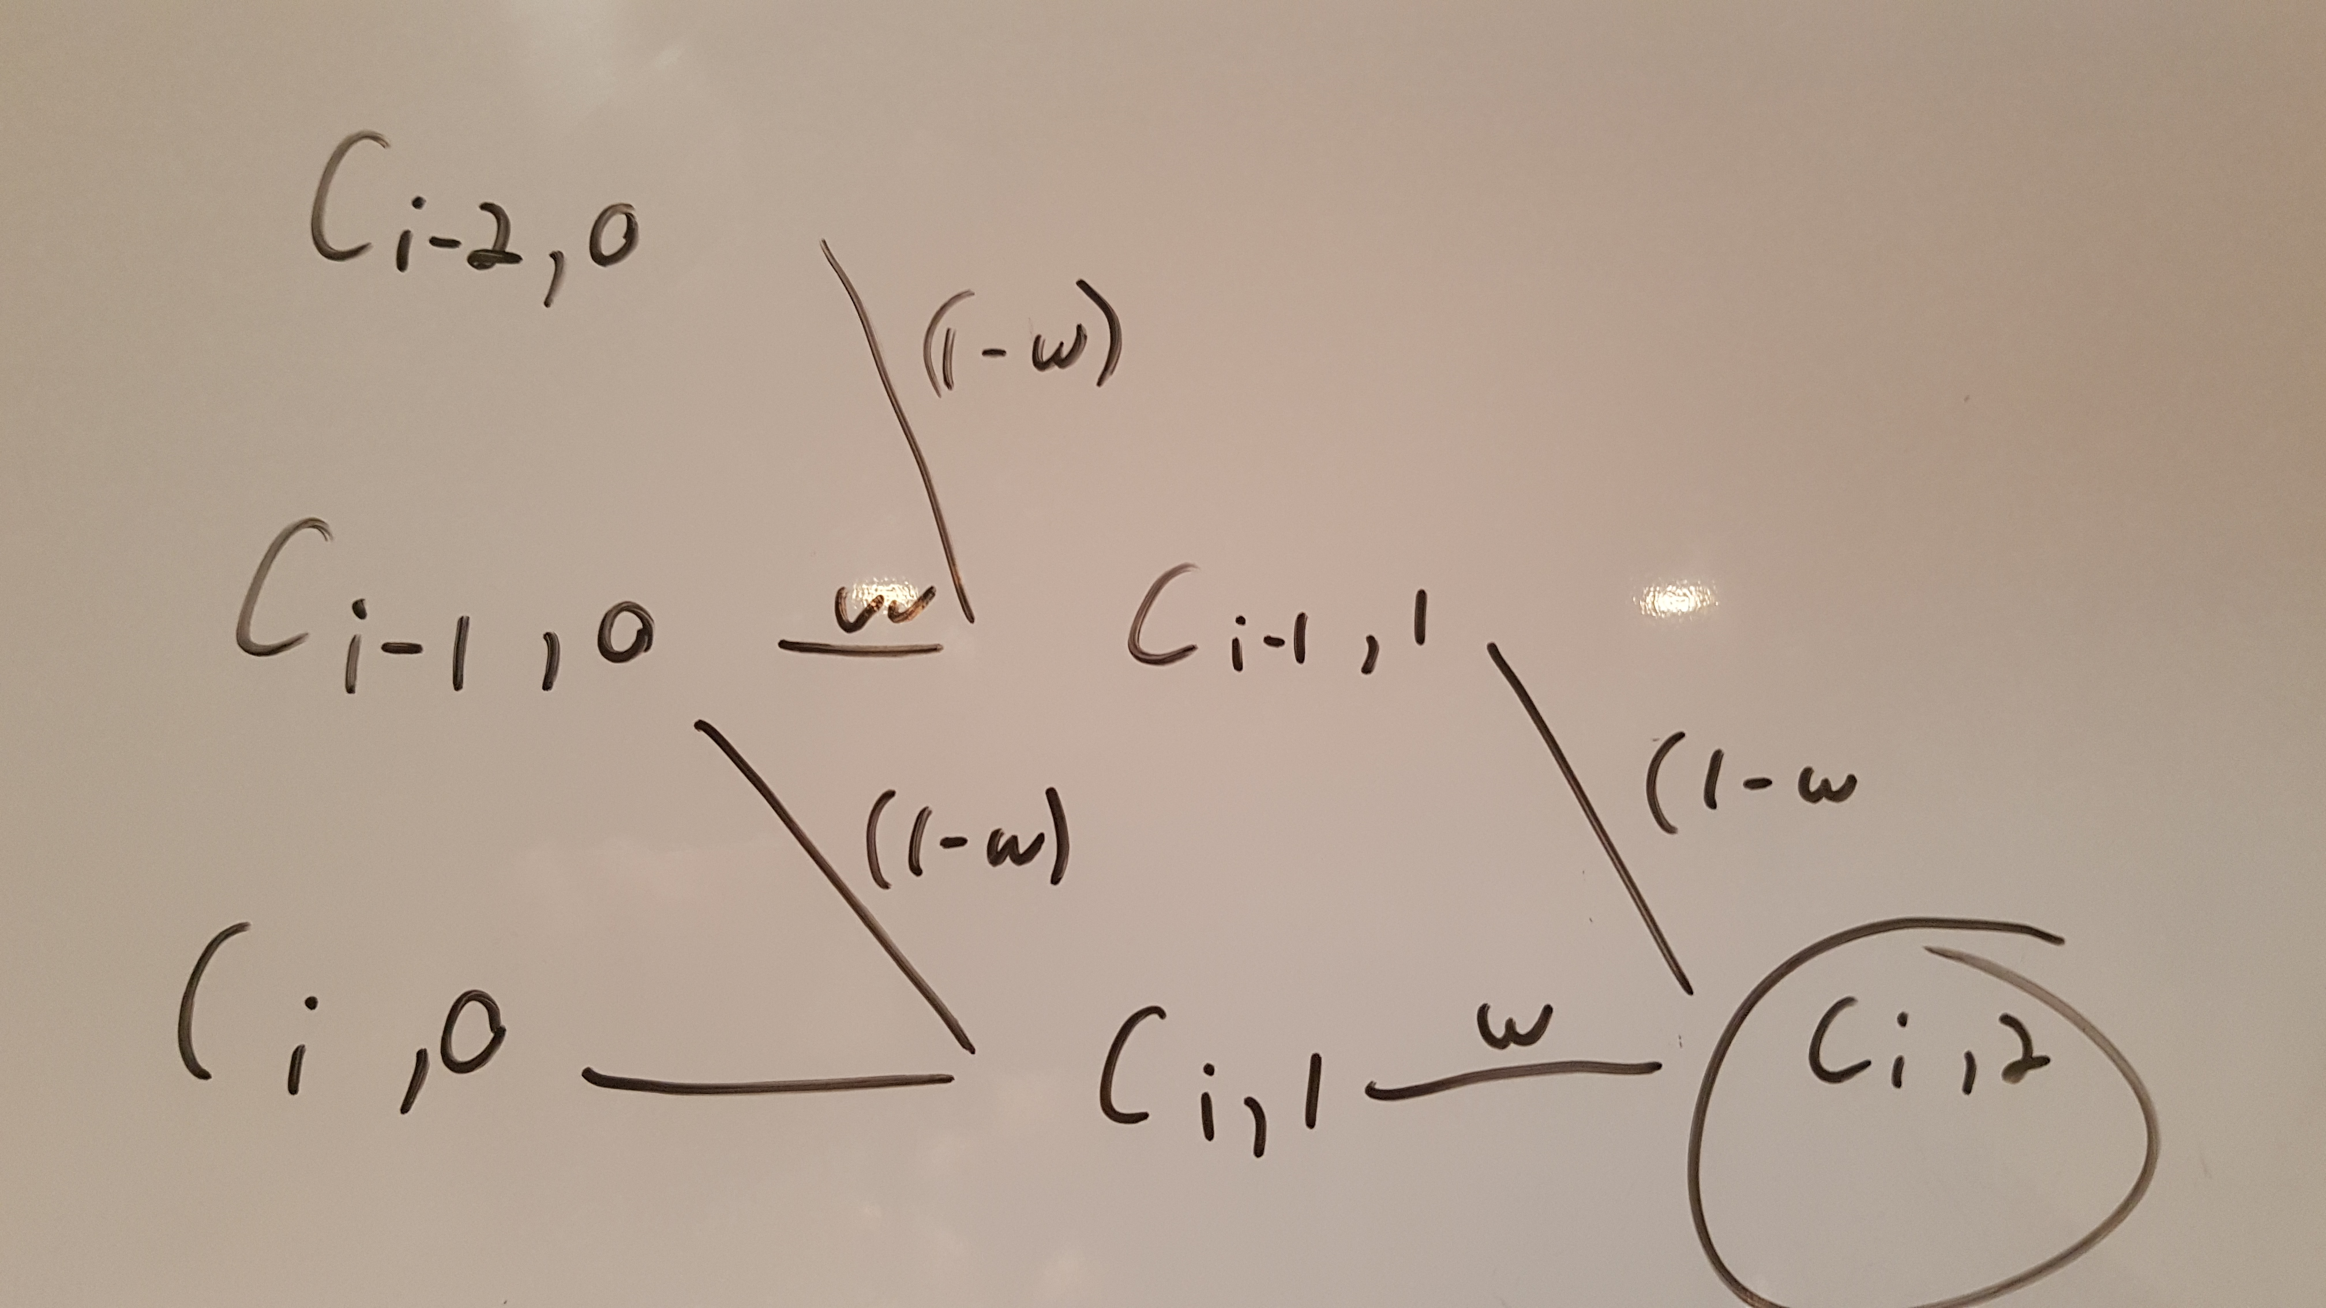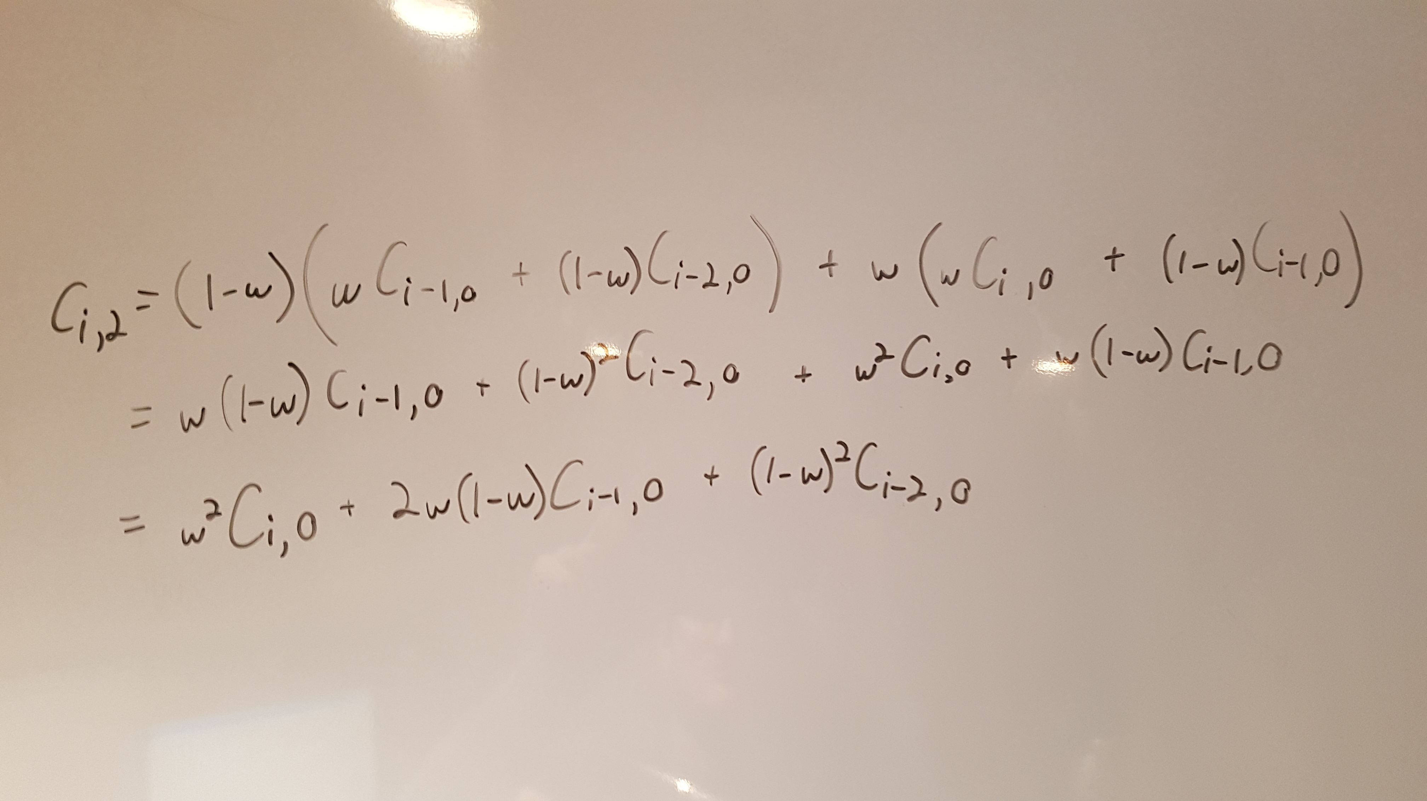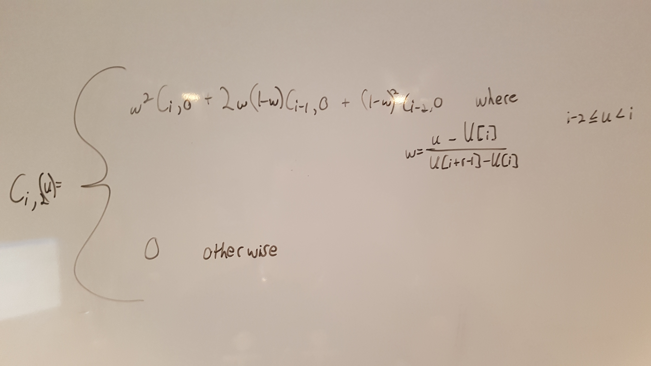

1. To do this I will use the formula for the efficient implementation of b-splines. Since we have 6 knot points and an order of 3 and we know that the number of knots is the order of the curve + the number of control points, we can determine that there are 3 control points. We also know that the delta index is 2 since u ranges from 0-1 and the knot values are either 0 or 1. Since our delta is 2, our order is 3 and the number of control points we have is 3, the range of control points that affects a single spot on the curve is the entire range of control points. Now that I have determined all the parameters, what I need to do is follow this pseudo-code and expand c[0].

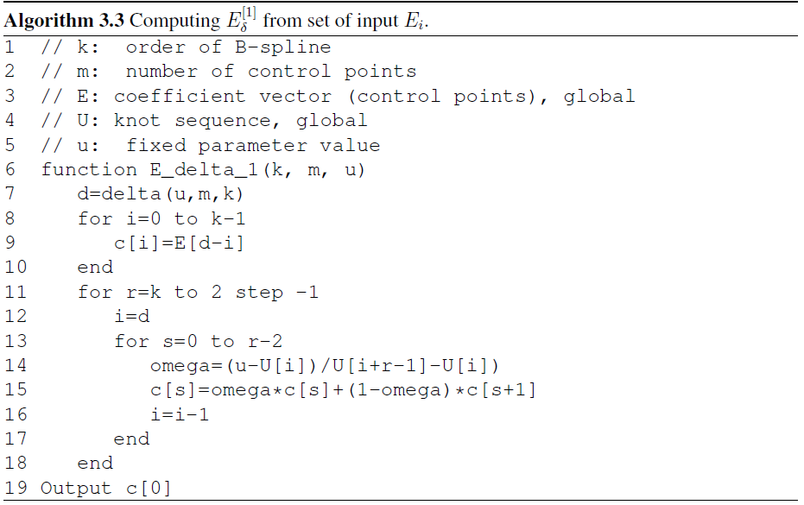Expand

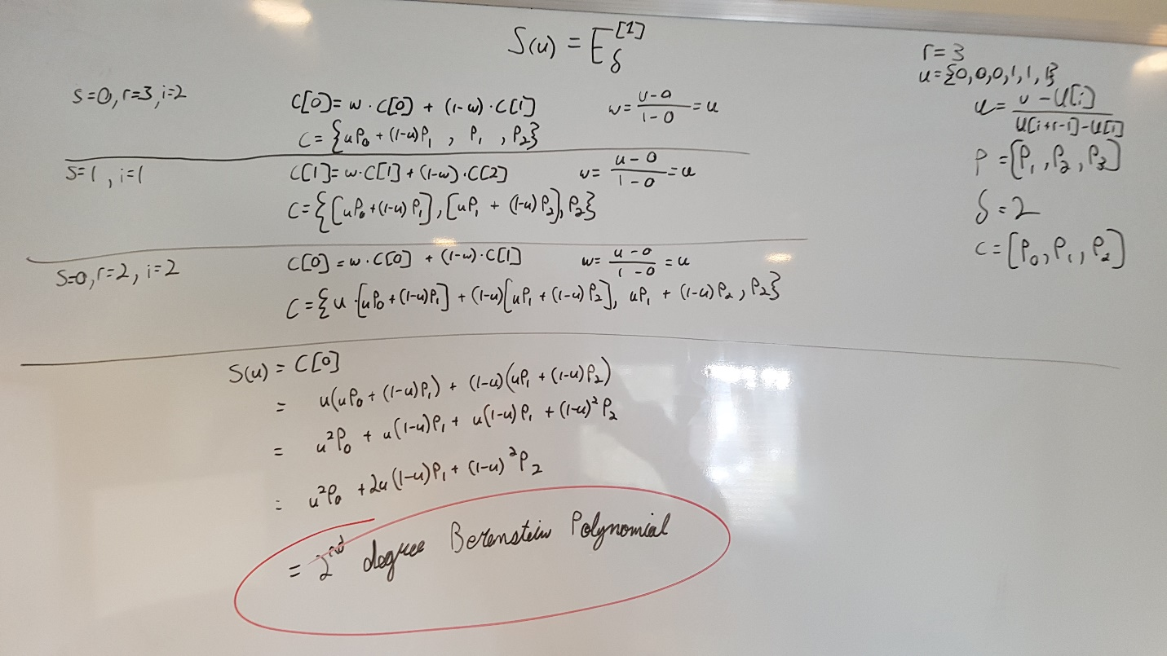We can see after the expansion that an order 3 B-spline is equivalent to a 2nd degree Berenstein Polynomial.

* 1. The total number of terms on the surface is 100 \* 200 = 20000 since u has 100 elements and v has 200 elements. Since u has 104 knots we also know that u has an order of 4 and since v has 203 knots that it has an order of 3. We know that for any given point on a b-spline, that the range of control points that factor into the point is equal to the degree of the curve. Therefore, for any point on the u curve, there are 4 active control points (terms) and 3 active control points (terms) on the v curve. Therefore, for any point on S(u, v), there 12 non-zero control points
  2. The delta value for a specific u is equal to the knot value where u>=U[i] and u<U[i+1]. Anything beyond that is not active in the point and is thus a zero term. We also know that the number of control points that affect a point on a curve is equal to the order of the curve. From this information, we know that the ‘order’ points below U[i + 1] where U[i + 1] > u are the control points that contribute to the curve.
  3. A third order b-spline has degree of 2. For a curve to be degree 2, it must be continuous at all derivatives up to the second derivative. Since we are looking at u when u=0, we only need to consider N = $\frac{u^{2}}{2}$ and $0$. Naturally, all derivatives of 0 are 0. N’ = u and N’’ = 0. At u = 0, all equations are 0 and therefore this is an order 3 curve.
  4. We need to shift the entire graph over by 5. All ranges need to be increased by 5 and since u will be 5 times larger, each u needs to be decreased by 5. The final equation will be which can be simplified to

